**[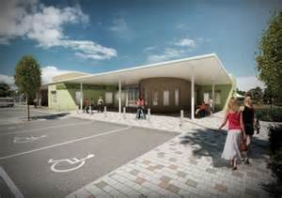](http://www.bing.com/images/search?q=mill+green++school+st+helens&view=detailv2&&id=E1099D8070A5DA7B123D5C2BEA6C9418841F1EB6&selectedIndex=3&ccid=7dMCiep2&simid=607999282079596627&thid=OIP.Medd30289ea76abc459b657570045beb8o0)**

**Destinations for**

**School Leavers from Lansbury Bridge School**

**Where did our pupils choose?**

|  |  |  |  |  |
| --- | --- | --- | --- | --- |
| **Year 12** | **Mill Green** | **Carmel** | **St Helens** | **Other** |
| **2018** | **14** | **3** | **0** | **0** |
| **2017** | **7** | **1** | **1** | **0** |
| **2016** | **15** | **2** | **0** | **0** |

Options for moving on from Lansbury Bridge School and beyond will be discussed during your child’s Education, Health and Care Plan Review meeting, and we endeavour to support you as much as we can in making your choice. Your child will also receive Careers Education, Advice and Guidance from Career Connect (previously Connexions) in school. Ann Kerry is our named advisor, and she works with groups of pupils and individuals.

As you can see from the table above, the majority of our pupils tend to move on to Mill Green College. From there, if they are still making academic or vocational progress, they may move on to Carmel College or St Helens College to further their education.

**Destinations for School Leavers from Lansbury Bridge School**

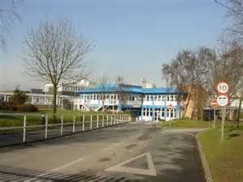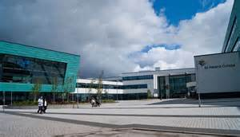

Most of our pupils choose to go to Mill Green when they leave Lansbury Bridge after Year 11. For the last 3 years, a number of pupils have also moved to Mill Green at the end of Key Stage 3; starting Year 10 at Mill Green. Please check the college website for more information.

For pupils with moderate learning difficulties, Carmel College is another option. Please check Carmel’s website for entry requirements and available courses.

St Helens College also has a Foundation Learning Department. A number of our pupils have enrolled here previously. Please check the college’s website for entry requirements and available courses.

The providers below operate independently of the Local Authority, and provide Post 19 options for young people with special educational needs.

Activate Independent – vocational programmes Knowsley

Acorn Farm Activities Knowsley

Midstream Horticulture / garden centre / café / admin Skelmersdale

Arden College Independent - Qualifications and work experience Southport